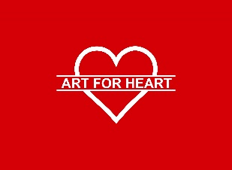
Art for Heart 2019
Exhibiting Artist | Application Form

All applicants MUST:
• Fill out this application form
• Provide pictures (high resolution jpegs) of their artwork
• Please email this form and pictures to Andrzej Pawlowski at Andrzej_ArtforHeart@yahoo.com

APPLICATION DEADLINE: FRIDAY, July 19th, 2019. (Please fill form)

Artist name ______________________________________________________________________________________

Artist’s Home Address _____________________________________________________________________________

e-mail _________________________________________________________________________________________

Phone ___________________________________________________________________________________________

Category (Check more than one box if submitting artwork in more than one category)

☐ 2-D Mixed Media – Includes collage and handmade paper; incorporates more than one type of material and has relief depth of less than 1/8 inch.
☐ 3-D Mixed Media & Sculpture – Original, non- functional, free- standing work of any material.
☐ Ceramics – Original shaped and fired clay (including earthenware, porcelain, stoneware and terra cotta).
☐ Digital Art – Original, two-dimensional works utilizing computer technology to craft or manipulate visual images.
☐ Functional Art –A functional, three-dimensional object which serve a purpose such as fiber objects, furniture, toys,
wind chimes, etc.
☐ Glass – An object made of glass (including blown glass and stained glass).
☐ Jewelry – The use of several different materials (such as clay, glass, metal and wood) to form a body adornment.
☐ Painting – The use of oil, acrylics, watercolor and tempera on canvas or board.
☐ Photography – Prints or transparencies must be from original negatives
☐ Works on Paper – A two-dimensional design on paper (including drawings, etchings, monoprints, pastels and silkscreens).

General comments (if needed) on your submission: _____________________________________________________________________________________________________________________________________________________________________________________________________________________________________________________________________________________________________________________________________________________________________________________________________________________________________________________________

In a few words, please describe what makes you Polish or of Polish descent. You may write in English or Polish.
________________________________________________________________________________________________________________________________________________________________________________________________________________________________________________________________________________________________________________________________________________________________________________________________________________

Price Range of Art: ___________________________________

